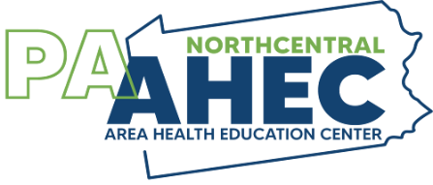
Oral Health Conference 2023
Friday, September 15, 2023
Pennsylvania College of Technology
Auditorium—Klump Academic Center
One College Avenue
Williamsport, PA 17701

Registration begins at 7:45 a.m.
Program: 8:30 a.m. to 1:00 p.m.
Registration: http://ncpaahec.org/programs/oral-health-conference/

Lillian Caperila, RDH, BSDH, M.Ed., FADHA

“Periodontal Therapy in 2023: It Takes a Village”

Emerging from an unprecedented year in a global pandemic, the challenges forced on the dental team has strengthened our resolve to adapt new protocols going forward. As we approach a new year in 2023, our management of disease transmission and oral disease prevention will be tested as a result of the revised periodontal classifications and patient care processes.
In 2018, the American Academy of Periodontology published new guidelines entitled: “Three Steps to Staging and Grading a Patient” and “Staging and Grading Periodontitis.” This program will review the steps in implementing the new guidelines, patient screening, diagnosis, treatment planning and appropriate therapies. Achieving successful outcomes is contingent on optimal instrumentation skills in compliance with the dental setting of 2023.

“The Mystique in Changing Patient’s Behavior: Motivational Interviewing”

The concept of “motivational interviewing,” - now recognized in oral healthcare as becoming the best practice in “guiding” our patients in making positive changes in their health and lifestyle behaviors.
By eliminating those prior tactics of judging or controlling our patients, we are now embracing a more effective “patient-centered approach to coaching. Our patients will only make positive changes if they can appreciate the value as well as making those choices on their own time.
Lil will walk the audience through the key principles that underscore the process of using motivational interviewing techniques in our workplace. The video clips and interactive discussion brings about a productive environment for learning this concept while having fun during the seminar.

For more information contact Marlene Doan at 570-724-9145 or officemanager.ncpaahec@gmail.com
Speaker Sponsorship arranged through

